1. **Create a table with your own data and perform all the commands of What-if Analysis.**

Ans.

Step 1: Create the following Table using formula as follows:-

Total Revenue(C5) = Price(C3) * Qty(C4)

Transport Cost(C6) = Total Revenue(C5)*10%

Item Cost(C7) = 20*Qty(C4)

Total Cost(C8) = Transport Cost(C6) + Item Cost(C7)

Profit = Total Revenue(C5)-Total Cost(C8)

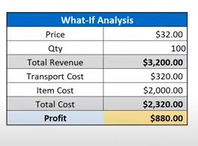

Step 2: Let’s first discuss about how to work with **scenario manager.**

Go to the Data Tab and somewhere around top right corner you can see What-If Analysis, just click on it and click on scenario manager as shown in the figure below.

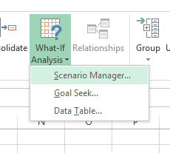

Step 3: Let’s see what changes in profit is seen as there is change in quantity

You can put any values according to your choice. But in this case let’s put

Qty = 200. Follow the figure below.

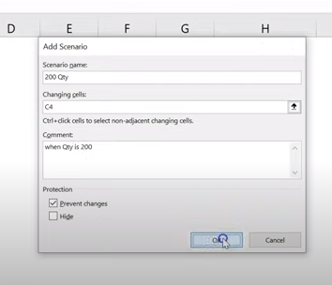

Then we are only changing for C4 so type 200 in the box and click ‘Ok’ as shown in figure below.

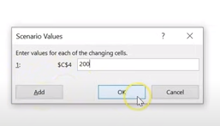

Then you can see 1 scenario has been added.

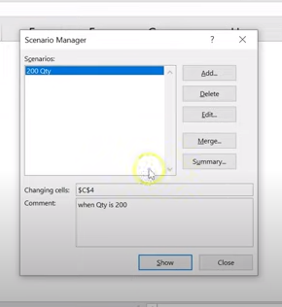

Similarly you can add 2 other scenarios for Qty = 200 & 300 as follows:-

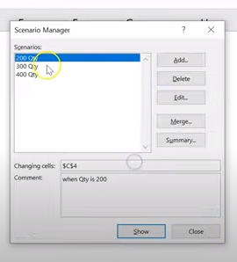

And you can check for different scenarios.

Select first scenario and click ‘show’ then the table will be as follows:-

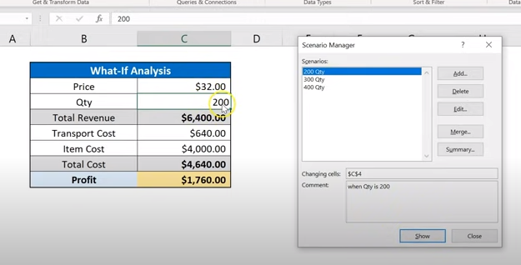

Similarly you can check for other scenarios as well.

For Qty=300,

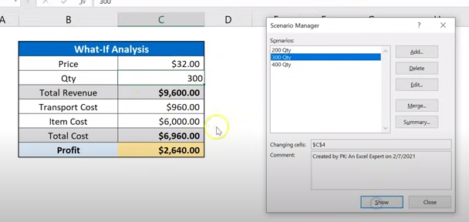

For Qty=400,

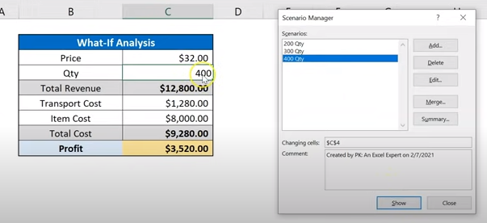

So of all these different scenarios you can create a summary by just clicking the ‘summary’ button.

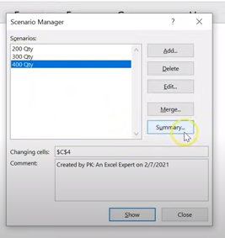

After clicking ‘summary’,

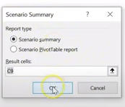

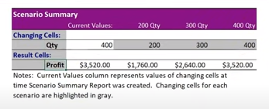

Step 4: After scenario manager we have **Goal Seek** under what-if analysis.

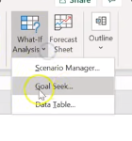

So to see or calculate how much quantity is required to get $5,000 profit, it is time consuming task for us in that case we can use goal seek under What-if analysis.

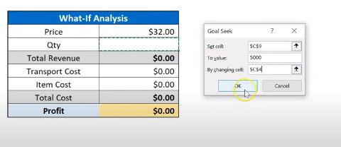

The figure below shows how much quantity is required to get $5,000 profit.

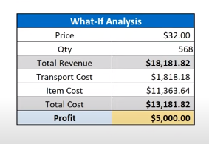

Step 5: After goal seek another and last function under what-if analysis we have is the **data table**.

To quickly see how much profit is made in different values of quantities we can use data table function. Make the table as shown in the figure below [G2=Profit]

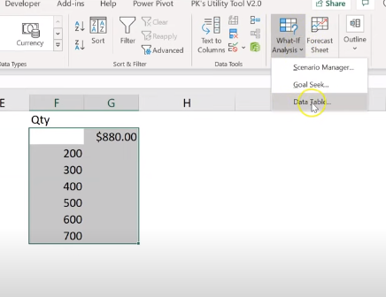

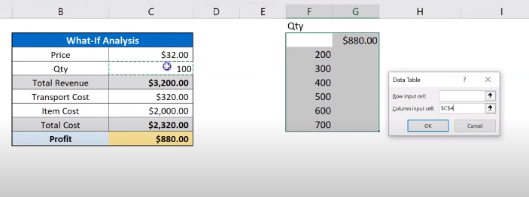

Since all different quantities lies in the same column, click on column box and select quantity because profit is dependent on Qty.

Click “ok” the result is as follows:-

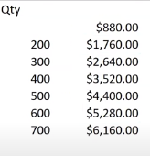

1. **Create a table with your own data and analyze the data using pivot table.**

Ans. We can create a table of products sales and listed them in a pivot table for better understanding. Pivot table is use for the summarized data of the table.

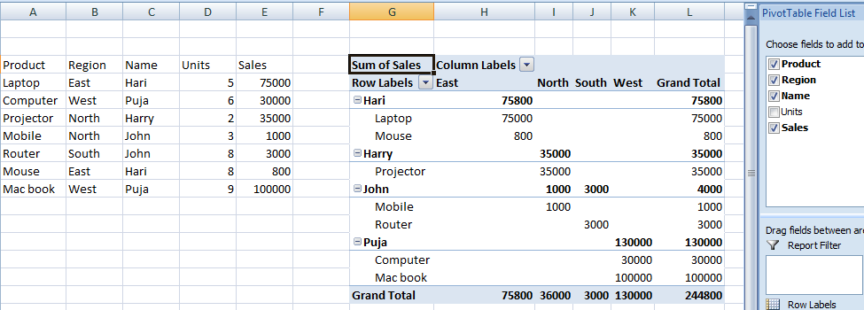

1. Prepare a report on all the Tabs of MS Excel.

Ans. There are nine tabs on the MS Excel: **File, Home, Insert, Page Layout, Formulas, Data, Review, View and WPS PDF.**

1. File = This provides a backstage view of commands related to files – to create a new sheet, to open a saved file, save a file, print the file and so on.

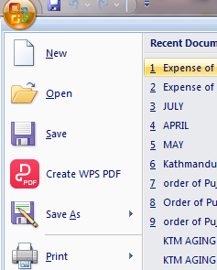

1. Home = this features is essential or most frequently used commands in excel – formatting, font types and filtering. We can use the copy, paste, font styles, color and size. We can insert, delete and format the cells. We can align the table or text using the alignment section.

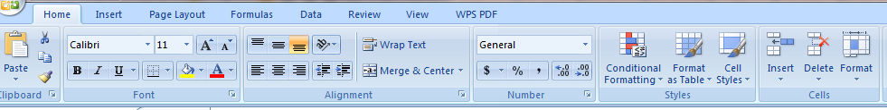

1. Insert = This is where you can add various items to a spreadsheet, including Pivot Tables, pictures, shapes, charts, graphs and symbols. 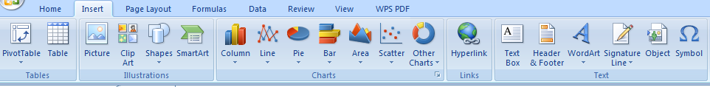
2. Page Layout = this allow you to customize the layout of the spreadsheet by adjusting the margins, color themes and print area. 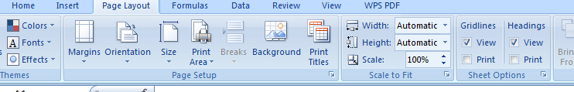
3. Formulas = this is where all essential formulas are categorized under the function library and it provides various controlling options. 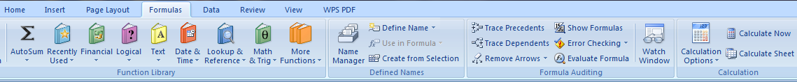
4. Data = this allows the user to manage data in the current spreadsheet, within the files, and also to import external data from other sources. 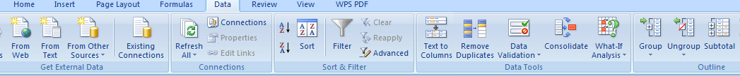
5. Review = this is for users to perform various controlling functions, including spell check, translate, adding comments and notes and also enables worksheet protection. 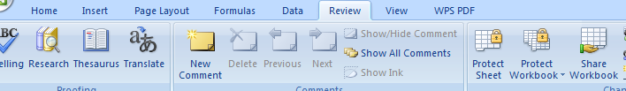
6. View = this provides options to alter the views of worksheets – gridlines, zoom, freeze panes, and to switch widows. 
7. WPS PDF = this option helps to convert the PDF to excel, word, ppt. And also helps to split and merge the PDF.

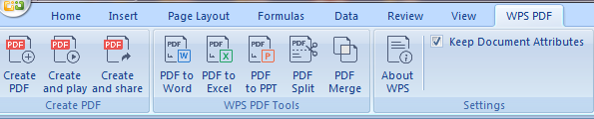

1. **Perform the following.**

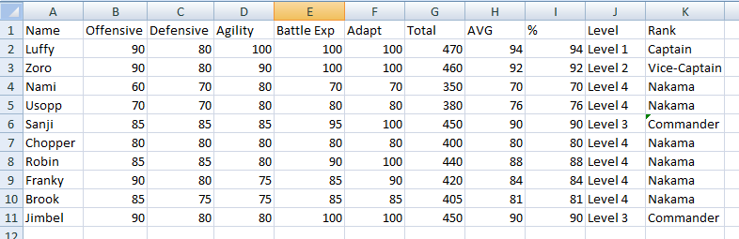

1. **Write a formula to find total of each member.**

Ans. Total = For Luffy: =SUM(B2:F2)

& Brook: =SUM (F10:B10) and so on.

1. **Write a formula to find AVG of each member.**

Ans. Let suppose all the attributes have 100 limits and the total of 5 attributes we get 500.

For Luffy: =AVERAGE(B2:F2) and so on.

1. **Write a formula to find percentage of each member.**

Ans. Percentage: (Total no. /500)*100%

1. **Write a formula to calculate level of each member.**

Ans. =IF(H2>=94,”Level 1”,H2>=94)

=IF(H3>=92,”Level 2”,H3>=92)

=IF(H6>=90,”Level 3”,H6>=90)

=IF(H4>=70,”Level 4”,H4>=90)

1. **Write a formula to find rank of each member.**

Ans. “Captain” for Level 1: =IF(I2>=94,”Captain”)

“Vice-Captain” for Level 2: =IF(I3>=92,”Vice-Captain”)

“Commander” for Level 3: =IF(I6>=90,”Commander”)

“Nakama” for Level 4: =IF(I4>=70,”Nakama”)

1. **Perform conditional formatting on it.**

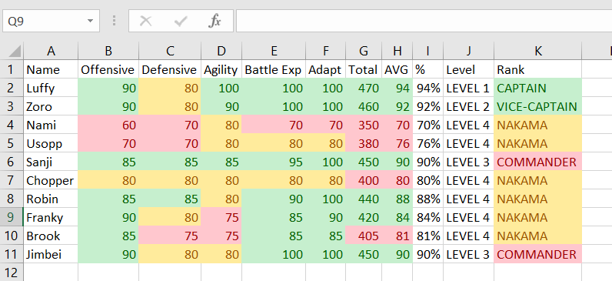

Trinity International College

Kathmandu, Nepal



**Assignment-III**

**(CFA)**

Submitted By: Submitted To:

Mohan Thapa Susan Sunuwar

Symbol No. BCA79110

BCA 1st Semester

Submission Date:17th Jestha, 2080